A
PROJECT REPORT ON
SERVICE@DOOR
SUBMITTED IN
PARTIAL FULFILLMENT OF

DIPLOMA IN ADVANCED COMPUTING (PG-DAC)
BY

MISS. SAMIKSHA GHUGARE
MISS. MAUSMEE JOSHI
UNDER THE GUIDENCE OF

AKASH SHELKE
AT

SUNBEAM INSTITUTE OF INFORMATION TECHNOLOGY,
KARAD

SUNBEAM INSTITUTE OF INFORMATION TECHNOLOGY,
KARAD.
CERTIFICATE
This is to certify that the project
SERVICE@DOOR

Has been submitted by
SAMIKSHA GHUGARE
MAUSMEE JOSHI
In partial fulfillment of the requirement for the Course of PG Diploma in Advanced Computing (PG-DAC AUG2015) as prescribed by The CDAC ACTS, PUNE.
Place: Karad | Date: 10-OCT-2019
AKASH SHELKE | DEEPESH MALVIYA
Project Guide | Alumni Mentor

ACKNOWLEDGEMENT

ABSTRACT

INDEX
 | INTRODUCTION | 1
 | 1.1 Introduction | 2
 | Product Overview and Summary
 | 2.1 Purpose
 | 2.2 Scope
 | 2.3 User Classes and Characteristics
 | 2.4 Design and Implementation Constraints
 | REQUIREMENTS
 | 3.1 Functional Requirements
 | 3.1.1 Use case for Administrator.
 | 3.1.2 Use case for Customer.
 | 3.2 Non - Functional Requirements
 | 3.2.1 Usability Requirement
 | 3.2.2 Performance Requirement
 | 3.2.3 Reliability Requirement
 | 3.2.4 Portability Requirement
 | 3.2.5 Security Techniques
 | PROJECT DESIGN
 | 4.1 Data Model
 | 4.1.1 Database Design
 | 4.2 Process Model
 | 4.2.1 Functional Decomposition Diagram
 | 4.2.2 Data Flow Diagram (DFD)
 | TEST REPORT
 | PROJECT RELATED STATISTICS
 | CONCLUSION
LIST OF TABLES
Section | Table Title | Page
1 | User(Customer, Vendor, Worker)
2 | Service Category
3 | Services
4 | Role
5 | Services Booking
6 | Service Feedback
7 | Offer
8 | Offer Details
9 | Membership
10 | Membership Details
11 | Payment
12 | OTP Details
13 | Location

LIST OF FIGURES
Section | Figure Title | Page
1 | Use Case - User
2 | Use Case - Worker
3 | Use Case - Admin
4 | E-R model diagram

SCOPE
Using this project e-house hold services “SERVICES@DOOR”, it reduces manual work by searching for workers and reliability 0on the workers as he/she comes from a renowned organization.
It also provide opportunity to the workers to find customers.

1. USE CASE DIAGRAM :

1- ADMIN
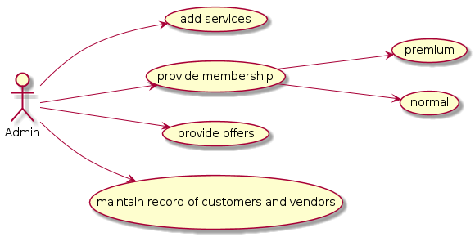

ADMIN:
The main functionalities of Admin is to manage all the database . Where Admin will add or delete the services. Admin will provide offers to the regular as well as new customers. Also he will provide membership. All the records of customer and vendor will be maintain by admin.

2- CUSTOMER
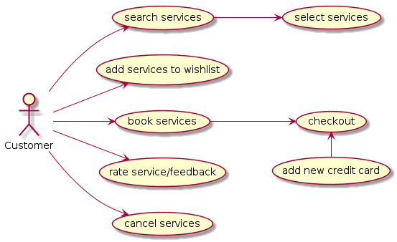

CUSTOMER:
If the customer is new he/she need to register first. Once he/she registered , he/she will login or sign up. Customer will search the services accordingly he can select and book the services . Also can add to wish list. Customer can rate the services . Customer can cancel the services . After booking he/she will do payment online.

3- VENDOR
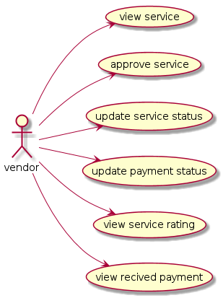

VENDOR:
Once the customer book the service , vendor can view the service which is assign to it, by the admin. If vendor is free and available then he/she will approve the service . Once approved he will change its status to working and after completion again he will update its status to free. After receiving payment he will update payment status. The reviews given by the customer could be visible to vendor . Vendor can check his/her daily payment.

4- COMMON FUNCTIONALITIES
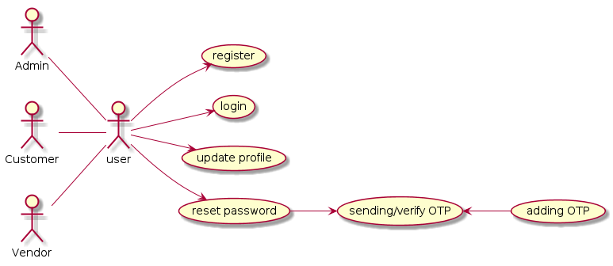

Admin ,Customer and Vendor shares some of the common functionalities such as Registration, login , upload profile and reset password.
All the new customer and vendor have to register first. Once customer and vendor have registered then they can login and can update all their information. They can update their profile, reset password.
During reset password OTP will be send and after verifying OTP password will be set.

2.USER INTERFACE DESIGN:

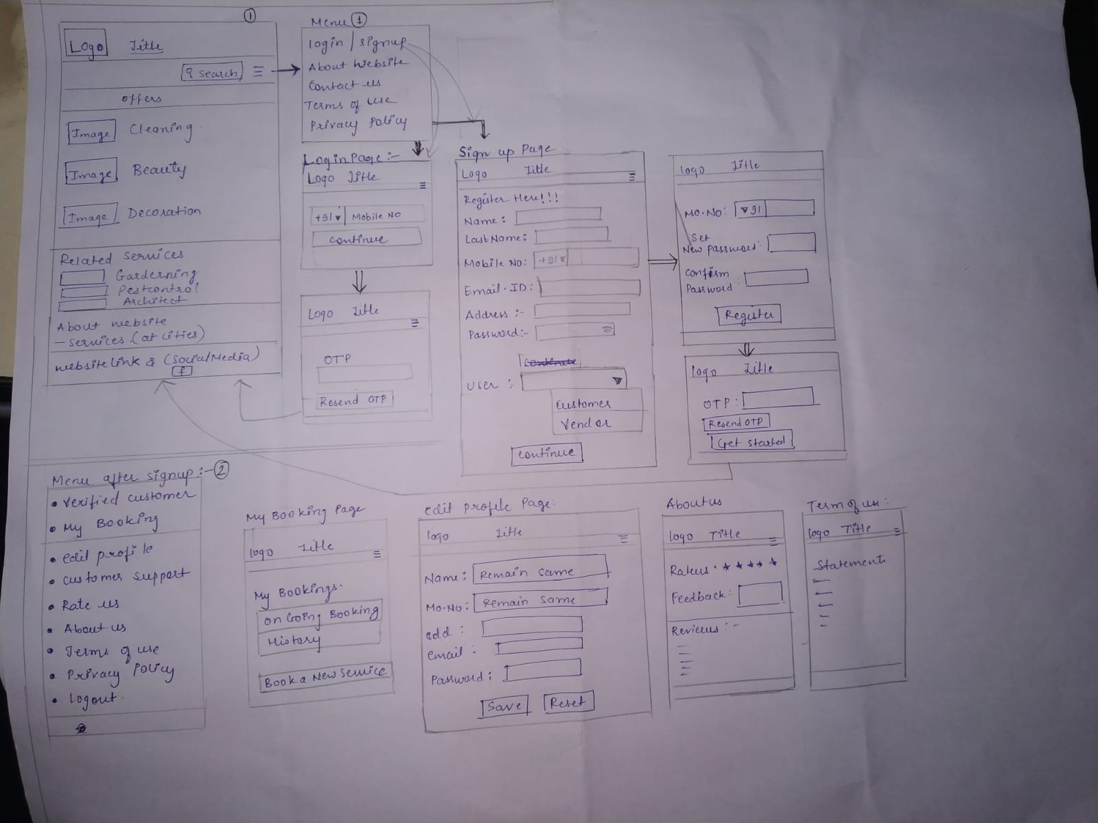
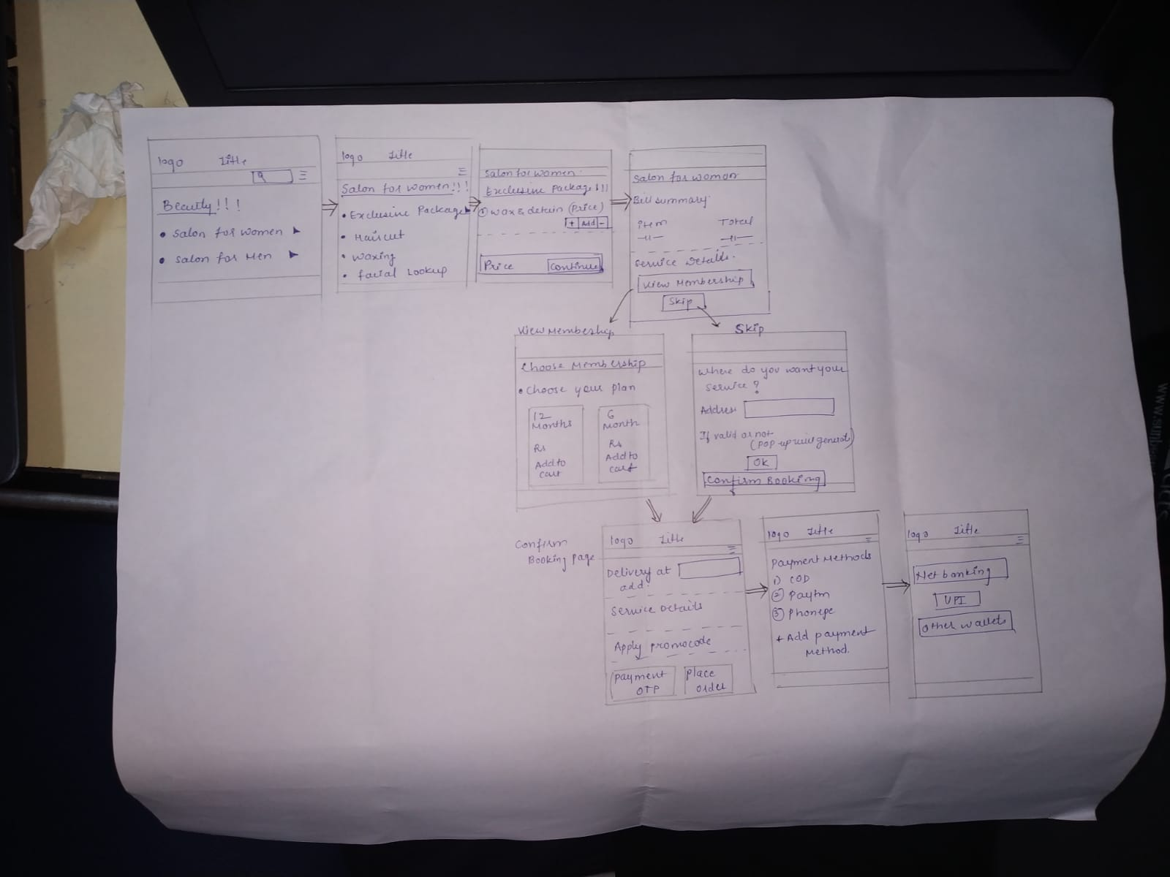

3. Database Design:

TABLE 1: USER(Customer, Vendor, Worker)
Key Type/ Constraint | Column Name | Data Type | Length | Allow Null (1=Yes;0=No)
PK | User_ID | int | 11 | 0
 | Name | varchar | 50 | 0
 | Gender | varchar | 50
FK | Location_ID | int | 11 | 0
UNIQUE (NOT NULL) | Email_ID | varchar | 50 | 0
UNIQUE (NOT NULL) | Mobile_No | varchar | 50 | 0
FK | Role_ID | int | 11 | 1

TABLE 2: Service_Category

Key Type/ Constraint | Column Name | Data Type | Length | Allow Null (1=Yes;0=No)
PK | Service_Cat_id | int | 11 | 0
 | Service_Cat_Name | varchar | 50 | 1

TABLE 3: Services

Key Type/ Constraint | Column Name | Data Type | Length | Allow Null (1=Yes;0=No)
PK | Service_ID | int | 11 | 0
FK | Service_cat_id | int | 11 | 1
 | Service_name | varchar | 50 | 0
 | Service_description | varchar | 100 | 1
 | Service_amt | float | 11 | 0

TABLE 4: Role

Key Type/ Constraint | Column Name | Data Type | Length | Allow Null (1=Yes;0=No)
PK | ROLE_ID | int | 11 | 0
 | Role_Name | varchar | 50 | 1

TABLE 5: Service_Booking
Key Type/ Constraint | Column Name | Data Type | Length | Allow Null (1=Yes;0=No)
PK | Booking_ID | int | 11 | 0
FK | Service_ID | int | 11 | 0
FK | User_cust_ID | int | 11 | 0
FK | User_Worker_ID | int | 11 | 0
FK | Location_ID | int | 11 | 0
 | Service_status | Tiny int | 1 | 1
 | Book_Date_Time | DateTime |  | 0

TABLE 6: Service_Feedback

Key Type/ Constraint | Column Name | Data Type | Length | Allow Null (1=Yes;0=No)
PK | Feedback_ID | int | 11 | 0
FK | User_Cust_ID | int | 11 | 0
FK | Booking_ID | int | 11 | 0
FK | User_vendor_ID | int | 11 | 0
 | Rating | int | 5 | 1
 | Feedback | varchar | 100 | 1

TABLE 7: Offer

Key Type/ Constraint | Column Name | Data Type | Length | Allow Null (1=Yes;0=No)
PK | Offer_id | int | 11 | 0
 | Offer_Name | varchar | 50 | 0

TABLE 8: Offer_Details

Key Type/ Constraint | Column Name | Data Type | Length | Allow Null (1=Yes;0=No)
FK | Offer_ID | int | 11 | 0
FK | User_ID | int | 11 | 0
FK | Service_ID | int | 11 | 0
 | Offer Discount | float |  | 1

TABLE 9: Membership

Key Type/ Constraint | Column Name | Data Type | Length | Allow Null (1=Yes;0=No)
PK | Memship_id | int | 11 | 0
 | Memship_Name | varchar | 50 | 0
TABLE 10: Membership_Details
Key Type/ Constraint | Column Name | Data Type | Length | Allow Null (1=Yes;0=No)
FK | memship_ID | int | 11 | 0
FK | User_ID | int | 11 | 0
FK | Service_ID | int | 11 | 0
 | mem_validity | DateTime |  | 1
 | mem_amt | int | 11 | 0

TABLE 11: OTP_Details
Key Type/ Constraint | Column Name | Data Type | Length | Allow Null (1=Yes;0=No)
PK | OTP_ID | int | 11 | 0
FK | USER_ID | int | 11 | 0
Unique | OTP | int | 11 | 0
 | Start_time | datetime |  | 1
 | End_time | datetime |  | 1

TABLE 12 : Location
Key Type/ Constraint | Column Name | Data Type | Length | Allow Null (1=Yes;0=No)
PK | Location_ID | int | 11 | 0
 | City | varchar | 50 | 0
 | Pin_Code | int | 11 | 0
 | State | varchar | 50 | 0

TABLE 13: Payment

Key Type/ Constraint | Column Name | Data Type | Length | Allow Null (1=Yes;0=No)
PK | Payment_ID | int | 11 | Key Type/ Constraint
Unique | Transaction_ID | int | 11 | PK
FK | Booking_ID | int | 11
 | Service_Amount | float

E-R model :
